Lab # 01: Arrays, Strings, Functions, Pointers, Structures, and Object as Node

Lab Policy and Rules:
1. 100% attendance is mandatory. In case of an emergency, up to 3 absences may be availed. Do not waste your absences; save them for emergencies. If you are debarred from the course due to low attendance, this cannot be corrected later.
2. Disturbing the class environment during lab sessions (such as talking, using mobile phones, eating, etc.) will result in penalties, such as deduction of marks.
3. Lab tasks will not be accepted if you are absent. If you miss a lab, you cannot submit that lab task.
4. Lab demos for each lab task will be conducted at the end of each session. If you miss the demo for any reason, no retake will be allowed, and that lab will be marked as 0.
5. All quizzes will be unannounced. Be prepared for surprise quizzes. Quizzes will cover content from previous labs as well as theory lectures from the corresponding theory course.
6. Use of AI is strictly prohibited. Anyone found using AI or copying code from a fellow student will be marked 0 in the lab task. You should be able to explain the syntax and logic used in your own tasks.
7. Do not ask for personal favors. If you have concerns, such as short attendance, please speak to the relevant authority (e.g., academics).
8. Students on warning: Now is the time to study and earn a good grade. Do not ask for extra marks at the end if you are unable to clear your warning.

Learning Objectives:
- Review the fundamental building blocks of C++ that are used throughout this course, namely arrays, strings, functions, pointers, and structures.
- Understand how pointers work and how they are used together with functions and structures to build flexible programs.
- Get a first look at how an object can act as a node, which is the basic building block of the data structures covered later in this course.

Outcomes:
- Declare, initialize, and manipulate arrays and strings in C++.
- Write functions, pass arguments by value and by reference, and use function pointers.
- Define and use structures to group related data together.
- Explain, at a basic level, how an object of a structure or class can be used as a node, in preparation for upcoming linked data structures.

1. Arrays
An array is a collection of elements of the same data type that are stored in consecutive, or contiguous, memory locations. Instead of creating several separate variables to store related values, such as the marks of five students, a single array can be used to store all of these values under one name. Each element inside the array can then be accessed individually by using its position, which is called an index.
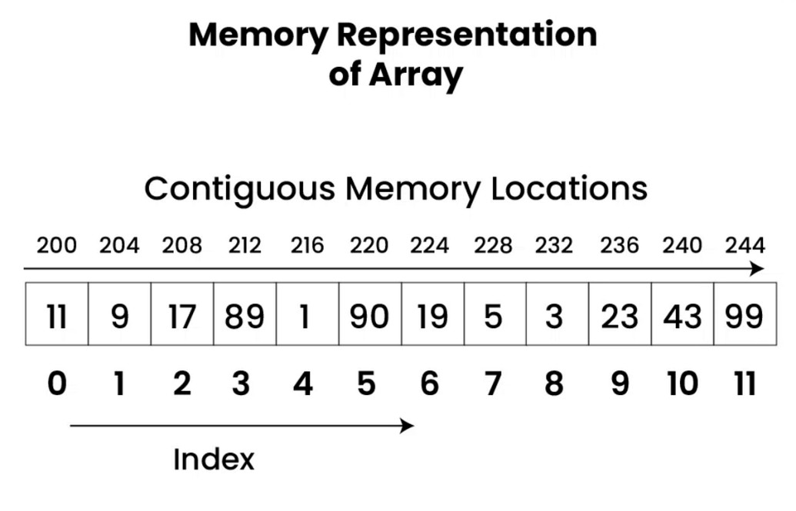

1.1 Declaring and Initializing an Array
An array is declared by writing the data type of its elements, followed by the name of the array, followed by the number of elements it will hold, written inside square brackets. For example, writing int marks[5]; creates an array named marks that is capable of holding 5 integer values, although at this point the values themselves are not yet defined.
The values of an array can also be provided immediately at the time of declaration. This is done by writing the values inside curly brackets, separated by commas, right after the array is declared. When the values are provided in this way, the size of the array can even be left empty inside the square brackets, since the compiler is able to count the values and determine the size automatically.
Sample Code:

1.2 Accessing and Modifying Array Elements
Each element of an array is accessed individually by writing the array name followed by the index of the desired element, enclosed in square brackets. It is important to remember that indexing in C++ always begins from 0, so the first element of the array is accessed as marks[0], not marks[1]. The same square bracket notation is also used to change, or update, the value stored at a particular index, simply by assigning a new value to it.
Since the valid indices of an array of size n range only from 0 to n - 1, care must be taken not to access an index outside of this range. C++ does not automatically stop a program from doing this, so accessing an invalid index does not usually cause an immediate error. Instead, the program ends up reading or writing memory that does not actually belong to the array, which leads to unpredictable and often incorrect behaviour.
Sample Code:
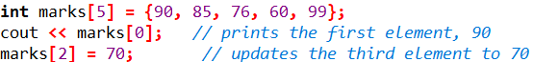

1.3 Traversing an Array
Traversing an array means visiting each of its elements once, which is normally done with the help of a loop. This is one of the most frequently performed operations on an array, since almost every task, such as printing, searching, or summing the elements, begins by traversing the array in this way.
A typical traversal begins by initializing a loop counter, usually named i, to 0, which corresponds to the first index of the array. A loop then continues to run as long as i remains less than the total number of elements in the array. On each pass through the loop, the element at index i is accessed and processed, for example by printing it to the screen, and then i is increased by 1 so that the loop moves on to the next element. This process repeats automatically until i becomes equal to the size of the array, at which point every element has been visited exactly once and the loop stops.
Sample Code:
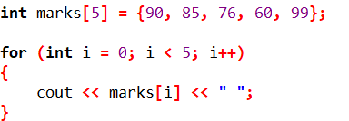

1.4 Arrays and Functions
An array can also be passed as an argument to a function, which is useful when the same operation, such as printing or searching, needs to be performed on the array in more than one place in a program. Unlike an ordinary variable, when an array is passed to a function, the function does not receive a separate copy of all its elements. Instead, it receives the address of the first element of the array, so any change made to the array inside the function is reflected in the original array as well, even though the reference operator (&) was not explicitly used.
Because the function only receives the address of the array and not the array itself, it has no way of knowing how many elements the array contains. For this reason, the size of the array must always be passed to the function as a separate parameter, so that the function knows where the array ends.
Sample Code:
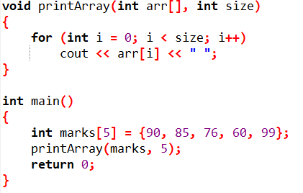

2. Strings
A string is simply a sequence of characters, such as a name or a sentence. In C++, a string can be represented in two common ways: as a C-style string, which is a character array that ends with a special null character, or as an object of the string class, which is provided by the C++ standard library and is generally easier and safer to use.
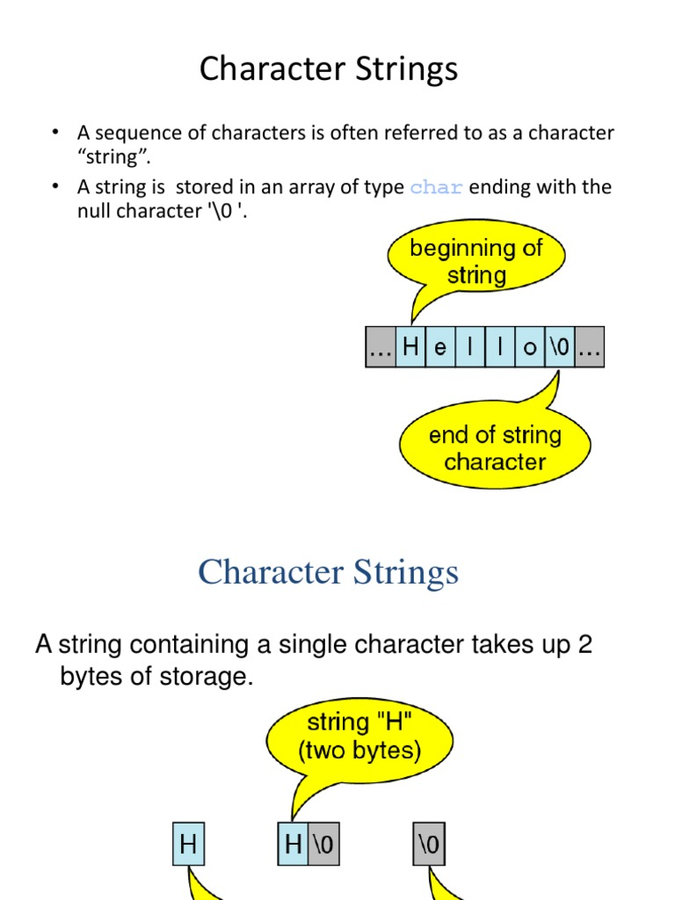


2.1 C-Style Strings
A C-style string is a character array in which the last valid character is always followed automatically by a special character, written as '\0' and known as the null character. This null character does not represent any visible symbol; its only purpose is to mark the point at which the string ends, so that functions working with the string know where to stop.
For example, when a character array is initialized with a piece of text enclosed in double quotes, the compiler automatically places the individual characters of the text into the array and then appends the null character after the last one, without this needing to be written explicitly.
Sample Code:

2.2 The string Class
The string class, made available through the <string> header, represents text in a way that is generally more convenient than a plain character array. A variable of type string manages its own memory internally, which means it can grow or shrink automatically as characters are added or removed, and it also provides several ready-made operations that would otherwise have to be written manually for a C-style string.
A string object can still be indexed in the same way as an array, using square brackets, since it internally stores its characters one after another in order, in the same manner as a character array.
Sample Code:
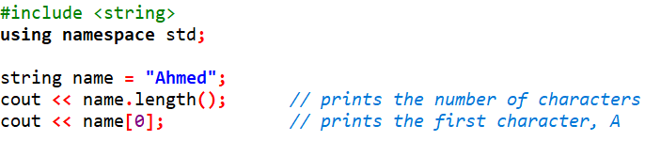

2.3 Common String Operations
The string class provides a number of member functions that make common tasks easier to perform:
- length() or size(): returns the total number of characters currently stored in the string.
- substr(pos, len): returns a portion of the string, starting at position pos and continuing for len characters.
- find(text): searches the string for the first occurrence of text and returns the position at which it begins, or a special value if it is not found at all.
- append(text) or the + operator: joins one string to the end of another, producing a longer combined string.
- compare(text): compares the calling string with another string and indicates whether they are equal, or which one comes first alphabetically.
Sample Code:
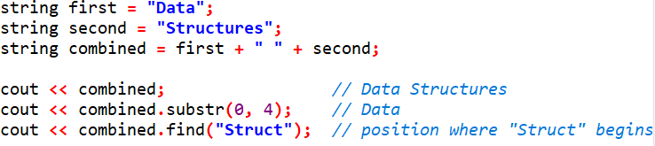

2.4 Traversing a String
Since a string is fundamentally a sequence of characters, it can be traversed in exactly the same way as an array, either with an index-based loop that runs from 0 up to one less than the length of the string, or with a range-based loop that automatically visits each character in turn without the need to manage an index manually.
Sample Code:
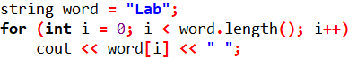

3. Functions and Function Pointers

3.1 Reviewing Functions
A function is a named block of code that is written once and can then be called, or invoked, as many times as needed from other parts of the program. Every function has a return type, which describes the kind of value it sends back to the caller, a name, which is used to call it, and a parameter list, which describes the values it expects to receive when it is called.
When a function is called, the program temporarily leaves the point of the call, executes the statements inside the function using the values that were passed to it, and then, if the function has a return type other than void, sends a value back to the exact point from which it was called.
Sample Code:
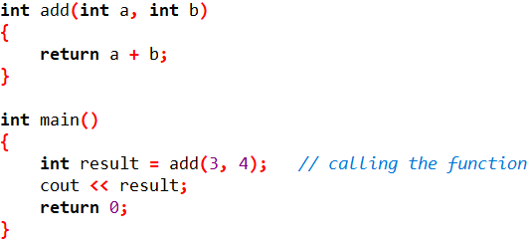

3.2 Pass by Value vs Pass by Reference
When an argument is passed by value, the function receives a separate copy of that argument, so any change made to the parameter inside the function has no effect on the original variable back in the calling code. This is the default way in which arguments are passed in C++.
When an argument is passed by reference instead, which is indicated by placing the reference operator (&) after the parameter's data type, the function does not receive a copy. Instead, it receives access to the original variable itself, so any change made to the parameter inside the function directly changes the original variable as well. Passing by reference is especially useful when a function needs to modify a variable that belongs to the calling code, or when passing a large object that should not be copied unnecessarily.
Sample Code:
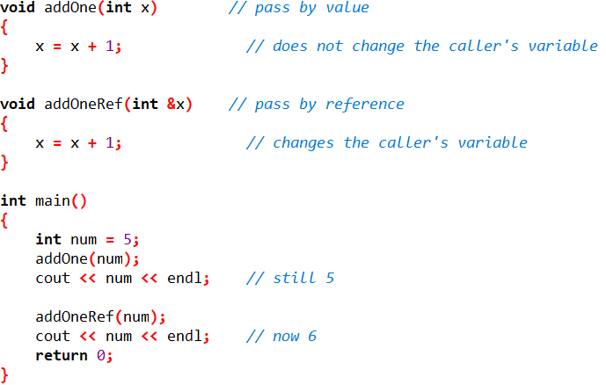

4. Pointers
A pointer is a variable that does not store an ordinary value, such as a number or a character. Instead, it stores the memory address of another variable. Every variable created in a program is placed somewhere in the computer's memory, and that location has its own unique address. A pointer allows this address to be stored and used, which makes it possible to access or modify the original variable indirectly, through the pointer, instead of through the variable's own name.

4.1 Declaring a Pointer and the Address-of Operator
A pointer is declared by writing the data type of the variable it is meant to point to, followed by an asterisk (*), followed by the name of the pointer. The data type used in the declaration must match the data type of the variable whose address will be stored, since this tells the compiler how to correctly interpret the memory at that address.
Once a pointer has been declared, it must be made to point to an actual variable before it can be used meaningfully. This is done using the address-of operator (&), placed directly before the name of an existing variable, which gives back the memory address at which that variable is stored. This address is then assigned to the pointer, after which the pointer is said to be pointing to that variable.
Sample Code:
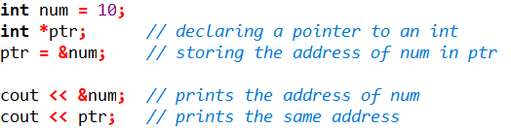

4.2 The Dereference Operator
Once a pointer holds the address of a variable, the value stored at that address can be accessed or changed using the dereference operator (*), placed directly before the pointer's name. Dereferencing a pointer means following the address it holds in order to reach the actual variable, and then either reading its current value or assigning it a new one. It is worth noting that the same asterisk symbol is used both when declaring a pointer and when dereferencing it, but the two uses happen in different situations and should not be confused with one another.
Sample Code:
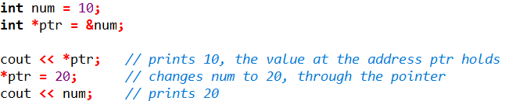

4.3 NULL Pointers
A pointer that is not currently meant to point to any valid variable should be assigned the special value NULL, rather than being left unassigned. A pointer that has not been given any value at all still contains whatever address happened to already be present in that memory location, and using such a pointer can lead to serious errors, since it may end up pointing to memory that does not belong to the program at all. Assigning NULL to a pointer makes it clear, both to the program and to anyone reading the code, that the pointer is not currently pointing to anything, and this can be checked before the pointer is used.
Sample Code:
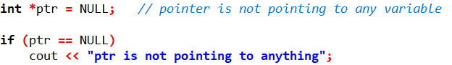

4.4 What is a Function Pointer
Just as an ordinary pointer stores the memory address of a variable, a function pointer stores the memory address at which a function's code begins. Once a function pointer has been made to point to a particular function, that function can be called indirectly through the pointer, instead of calling it by its name directly.
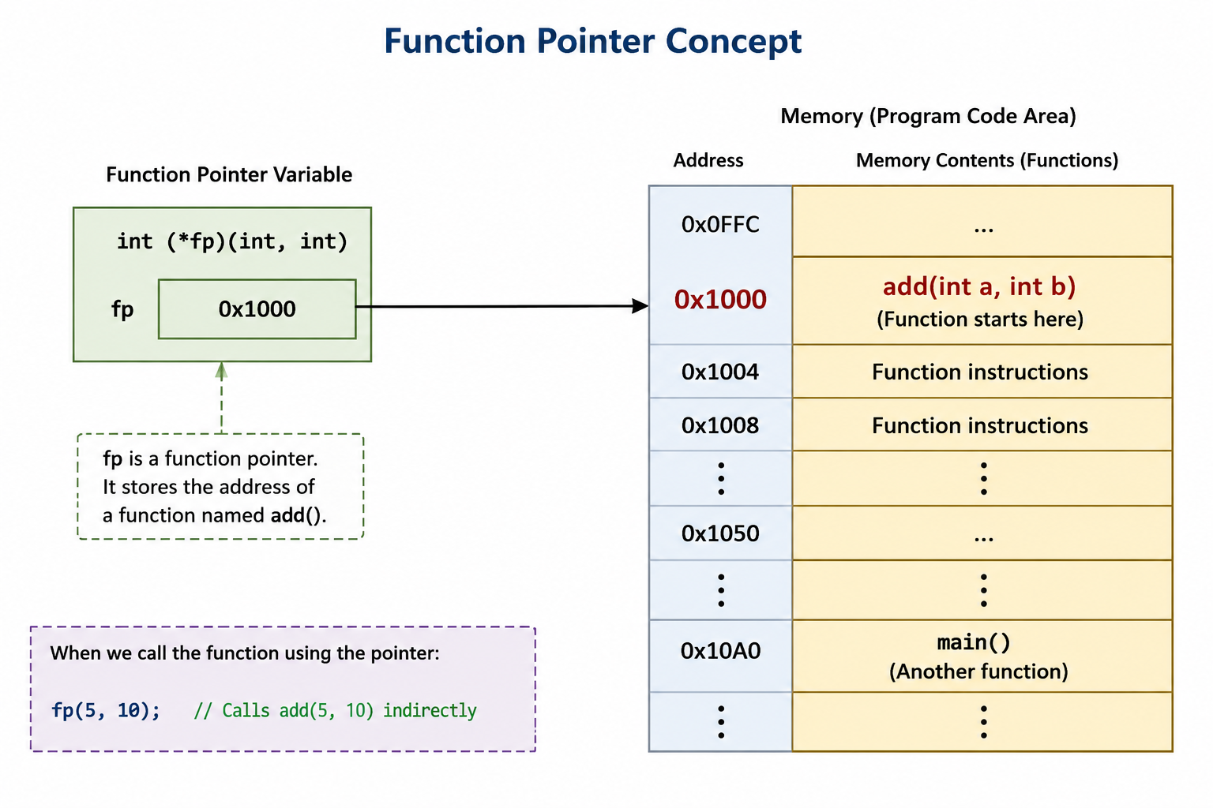

4.5 Declaring and Using a Function Pointer
The declaration of a function pointer must exactly match the return type and the parameter list of the function it is meant to point to, since this is how the compiler knows how the function should be called through the pointer. Once declared, the function pointer is assigned the name of an existing function, without parentheses, after which it can be called by writing the pointer's name followed by parentheses, in the same way an ordinary function would be called.
Function pointers become especially useful when a program needs to decide, while it is running, which one of several available functions should be called, or when a function needs to be passed as an argument to another function so that it can be called back later. This second use, generally referred to as a callback, is a common pattern in larger C++ programs.
Sample Code:
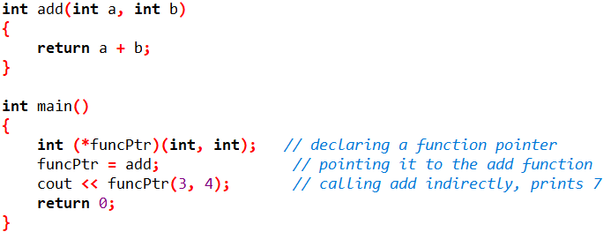

5. Structures
A structure is a user-defined data type that allows several related variables, called members, to be grouped together under a single name. Instead of managing several separate variables to describe one real-world entity, such as a student having a roll number, a name, and a GPA, a structure allows all of these related values to be stored and passed around together, as a single unit.

5.1 Declaring and Using a Structure
A structure is declared using the struct keyword, followed by the name of the structure, and then a set of curly brackets containing the list of member variables it will hold, each with its own data type. This declaration only defines what the structure looks like; it does not, by itself, create any actual data in memory.
- rollNo: an integer member that will store the roll number of a student.
- name: a string member that will store the name of a student.
- gpa: a floating-point member that will store the grade point average of a student.
Once a structure has been declared, a variable of that structure type can be created in the same way as any ordinary variable is created. The individual members of such a variable are then accessed by writing the variable's name, followed by a dot, followed by the name of the member.
Sample Code:
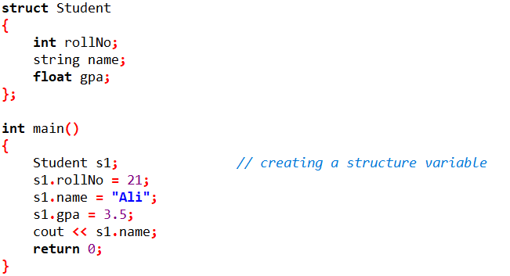

5.2 Structures and Pointers
A pointer can also be made to point to a structure variable, in the same way a pointer can point to any other variable, by storing the address of that structure variable. However, when the members of a structure are accessed through a pointer, the dot operator can no longer be used directly. Instead, the arrow operator (->) is used, which combines the steps of following the pointer and accessing the member into a single operation.
Sample Code:
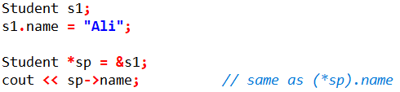

5.3 Structure vs Class
In C++, a structure is very similar to a class, and in fact, a structure is allowed to contain functions and constructors in exactly the same way a class does. The only real difference between the two is that the members of a structure are public by default, while the members of a class are private by default, unless stated otherwise. Because a structure can contain a pointer to another structure of the same type, this same idea is what makes it possible to build a node, which is the basic building block used in the data structures covered later in this course.

6. Object as Node (Overview)
Starting from the next lab, we will begin building data structures such as linked lists, stacks, queues, and trees. Although these data structures may look different from one another, all of them are built by repeating a small building block known as a node.
A node is nothing more than an object of a structure or a class that stores two kinds of things together: the actual data that needs to be kept, and one or more pointers that store the address of other node objects. This is the exact same structure concept that was covered above, with only one addition: instead of a member pointer pointing to a simple variable such as an integer, it points to another object of the same structure or class type.
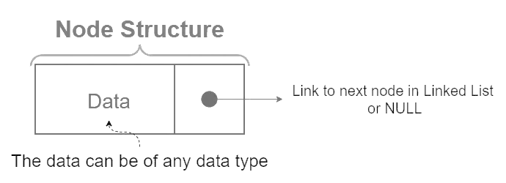
For example, a node meant for use in a simple list would contain a data member to hold a value, together with a pointer member, commonly named next, that is capable of holding the address of another node of the exact same type. By connecting many such node objects together through these pointers, one node at a time, a chain of nodes is gradually formed.
Sample Code:
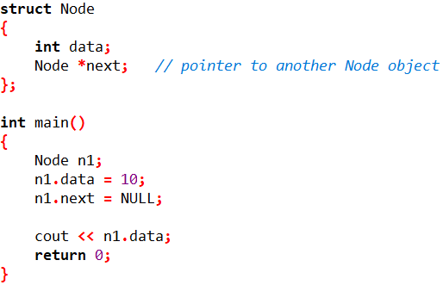
This is only meant to be a brief introduction, so that the term “node” does not feel unfamiliar going forward. The construction and use of nodes will be covered in complete detail, together with linked lists, starting from the next lab.

Lab Tasks
Attempt all tasks in the order given. For each task, write clean, working C++ code, test it with the sample scenario described, and be ready to explain any line of your code during the demo. Do not use STL containers such as vector, array, or built-in linked-list/stack classes in this lab use plain C-style arrays, pointers, and structures only, since the goal is to build the foundations, these will later replace.
Task 1: Arrays & Functions: Canteen Token Counter
Scenario: The FAST canteen issues a token number to every student who places an order during lunch break. At the end of the break, the canteen staff want a small program to analyze the day's tokens.
Write a C++ program that performs the following:
- Declare an integer array tokens[50] and read n (the number of orders, n ≤ 50) followed by n token numbers from the user into the array.
- Write a function double findAverage(int arr[], int size) that returns the average token value (this also tests that you understand a token value is just a number here, not an ID lookup).
- Write a function int findMax(int arr[], int size) and int findMin(int arr[], int size) that return the highest and lowest token numbers issued.
- Write a function int linearSearch(int arr[], int size, int key) that returns the index of a given token number if it exists, or -1 if it was never issued (use this to answer “was token 27 issued today?”).
- Write a function void reverseArray(int arr[], int size) that reverses the tokens array in place (no second array), since the manager wants to display today's tokens in reverse (most recent first).
- In main(), call each function and print the results in a clear, labelled format.
Constraint: every function must receive the array and its size as parameters (as discussed in section 1.4) no global arrays.
Output:
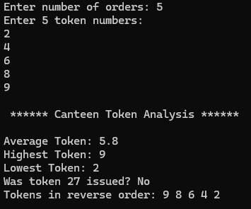
Task 2: Strings: Roll Number & Email Validator
Scenario: FAST issues roll numbers in the format 24I-1234 (2 digits for batch year, one letter for program, a hyphen, then 4 digits) and university emails in the format i241234@nu.edu.pk. The registrar's office wants a quick console tool to sanity-check student-entered data.
Using the C++ string class (not char arrays) and the member functions covered in section 2.3, write a program that:
- Accepts a roll number as a string and checks: (a) its length() equals 8, (b) index 2 is the character '-', and (c) the substr() before and after the hyphen contain the expected number of characters.
- Accepts an email as a string, uses find("@") to confirm an @ symbol exists, and uses find("nu.edu.pk") to confirm the domain is correct. Print an appropriate error if either check fails, e.g. “Missing @ symbol” or “Invalid domain”.
- Extracts the roll number embedded inside the email (the part before @, e.g. i241234) using substr(), and prints it separately.
- Uses compare() to check whether two student-entered roll numbers refer to the same student, and prints “Match” or “No Match” accordingly.
- Uses a traversal loop (either index-based or range-based, per section 2.4) to count how many digits appear in the roll number, to make sure exactly 6 digits are present.
Output:
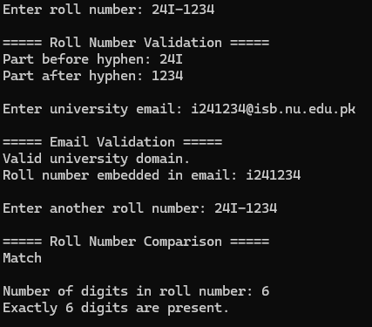
Task 3: Pointers: Fixing a Faulty Banking Function
Scenario: A junior developer at a bank wrote a C++ function to transfer a fixed processing fee from one account balance to another, but the balances never actually change after the function call, the bug is that everything is being passed by value.
- First, write the buggy version: void transferFee(double from, double to, double fee) that subtracts fee from from and adds it to to. Call it in main() with two double variables and show (with cout) that the original variables are unchanged.
- Now fix it by rewriting the function using pass-by-reference: void transferFee(double &from, double &to, double fee). Show that the original variables do change this time.
- Rewrite the same fixed function once more, but this time using pointers instead of references: void transferFee(double *from, double *to, double fee), using the dereference operator to read/modify the balances. Call it using the address-of operator on your variables.
- Write a function void swapBalances(double *a, double *b) that swaps two account balances using pointers, and use it to swap two sample accounts.
- In your program's comments, briefly explain (2–3 lines) why the very first version failed and why the reference/pointer versions work, you will be asked to explain this at the demo.
Output:
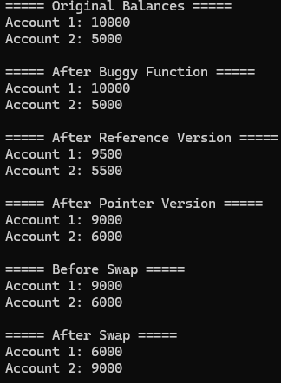
Task 4: Function Pointers: A Callback-Based Calculator
Scenario: The FAST Programming Society wants a simple calculator tool for a workshop, but they want it built so that new operations can be added later without changing the core menu logic this is exactly what function pointers are for.
- Write four functions with identical signatures: int add(int a, int b), int subtract(int a, int b), int multiply(int a, int b), int divide(int a, int b) (handle division by zero with an error message).
- Declare a function pointer type, e.g. int (*operation)(int, int), and an array of 4 such function pointers, one for each operation above.
- Display a menu (1. Add 2. Subtract 3. Multiply 4. Divide), read the user's choice and two integers, then call the correct function indirectly through the function pointer array (no if/else or switch chain to call the actual function the pointer array must do the dispatching).
- Write a driver function int compute(int (*op)(int, int), int x, int y) that takes any operation function pointer as a parameter (a callback) and returns the result, then call compute() by passing it different operation functions directly, e.g. compute(add, 5, 3).
Output:
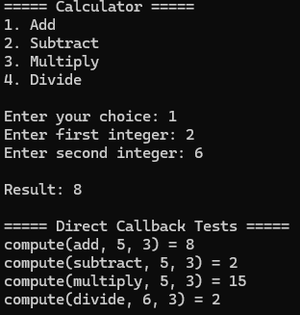
Task 5: Structures & Pointers: Mini Student Result System
Scenario: The Department wants a small console tool used during result-compilation week to store and process a batch of students' data before it is entered into the official system.
Define a structure:
struct Student { int rollNo; string name; float gpa; };
- Create an array of structures Student batch[10] and populate it for n students (n ≤ 10) by taking input from the user (roll number, name, GPA).
- Write a function void displayAll(Student arr[], int n) that prints all student records in a neat tabular format using the dot operator.
- Write a function Student* findTopper(Student arr[], int n) that returns a pointer to the structure of the student with the highest GPA (return the address, not a copy).
- In main(), receive that returned pointer and print the topper's name and GPA using the arrow operator (->), as described in section 5.2.
- Write a function void updateGPA(Student *s, float newGpa) that takes a pointer to a single Student and updates their GPA through the pointer, then call it by passing the address of one element of your array (e.g. &batch[2]) and confirm the change is reflected in the array afterward.
Output:
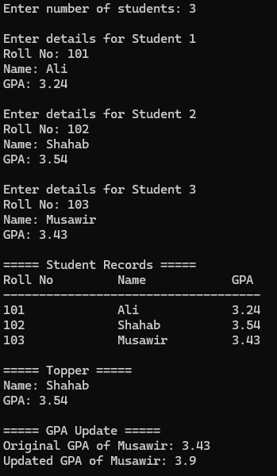

Task Submission Guidelines:
1. Make a document and paste all task solutions there (not screenshots) and save it as a PDF.
2. Along with each task solution, also include a screenshot of the output.
3. Include your name and roll number on the front page.
4. Submit your file in this format (Roll_number-name), for example 24I-1234-Ali.pdf.
5. Files other than PDF will not be accepted and will be marked as 0.

